***Experiment 9 Output***

This experiment involves designing and executing SQL queries to generate insightful reports from a data warehouse, utilizing business intelligence tools for data analysis and visualization.

***Creating Database and Data Table***

***Inserting Data Via SQL and Python***

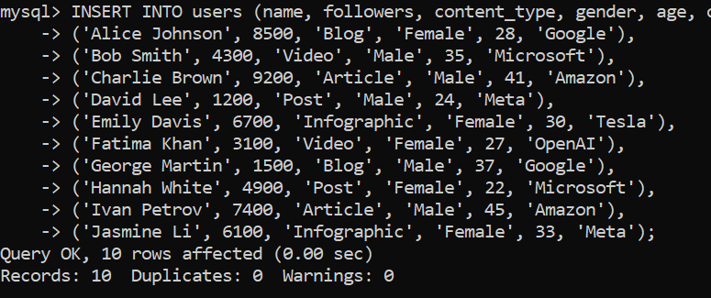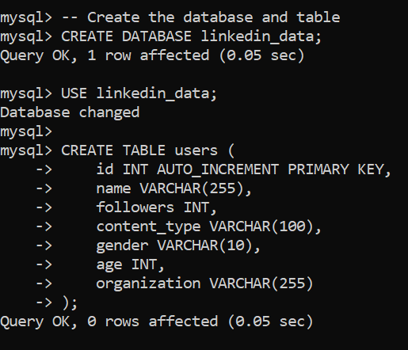

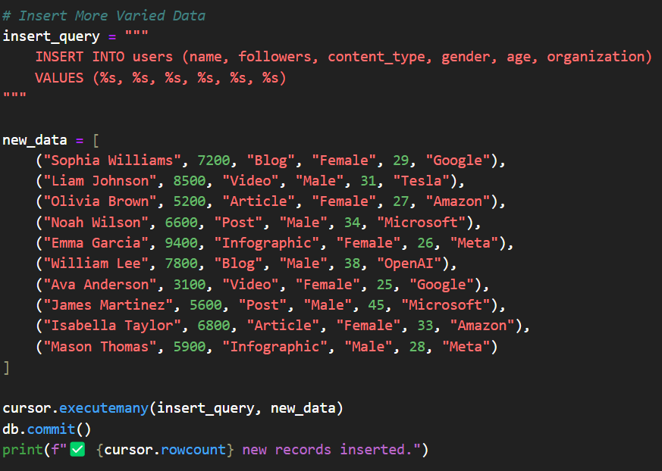

***Fig 1: Database and Table Creation***

***Fig 2: Data Insertion***

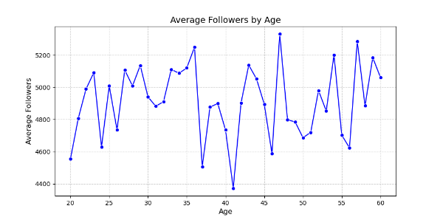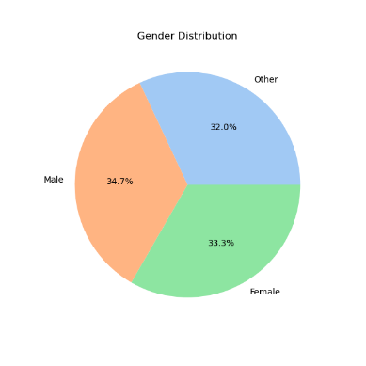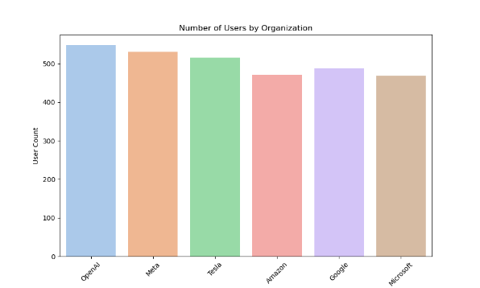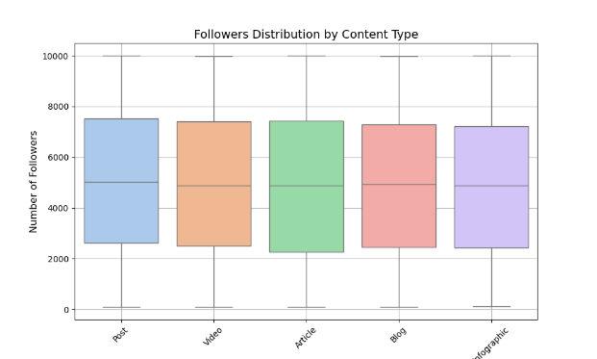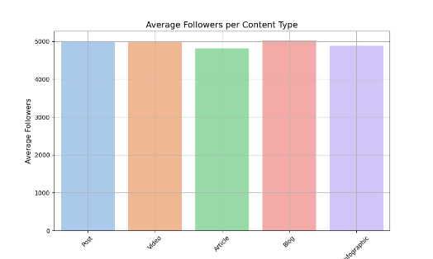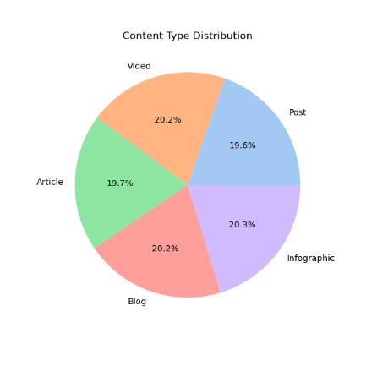

***Followers Distribution***

***Box Plot***

***Fig 4: Company and Users Distribution***

***Fig 3: Followers Distribution Graph***